**Joint Rig Committee**

**Upstream Property Values & Value Maintenance Guideline**

|  |  |  |  |
| --- | --- | --- | --- |
| Name | Date of issue | Version | Changes |
| JR2019-003 | 03 September 2019 | 1 | Original |

Upstream Property Values & Value Maintenance Guideline (JR2019-003)

Fixed Production Assets

This document has been prepared to provide an overview of upstream property values and value maintenance. This will assist underwriters to make better informed opinion regarding the accuracy and acceptability of values presented. This guideline considers the 3 below areas, emphasising that clarity in all 3 areas be established as part of the underwriting process:

* Valuation Basis – that advised by the assured (Operator)
* Indexation Basis (Value Maintenance) – that advised by the assured (Operator)
* Coverage Basis – the indemnification basis agreed under the insurance contract

The following table considers the variety of methods, used either singularly or in combination, on which the declared value basis being used for coverage purposes can be made. A ‘traffic light’ approach and relative position within the table is used to provide underwriters with a relative degree of confidence in the valuation.

|  |  |  |
| --- | --- | --- |
| **Valuation Basis** |  | **Comment** |
| New Risk CAR value |  | Project just coming off construction. |
| Assured adjusted CAR value |  | Ideally for assets < 3 old, where values have been adjusted to reflect recent material, labour, installation & engineered cost changes. |
| Assured benchmarked valuation within last 3 years |  | Benchmarking valuation supported by assureds Project and Engineering group, and reflects current construction costs based on actual year of account construction experience. |
| Valuation Company study within the last 3 years |  | Valuation should be from a reputable Valuation Company with proven recent and relevant experience, and able to demonstrate a current database of reference values. *(Could be yellow or green – depends on valuation basis / quality of work)* |
|  |
| Regional benchmark valuation less than 3 years old |  |  |
| Engineered value based on preferred alternative design in the event of major loss |  | Preferable to have an Engineered value based on an assured Project and Engineering group costed project. Some assureds may use commercially available cost estimation products such as Questor or similar. Concerns should start to be raised as to the risk of a total constructive loss arising from a partial loss scenario. |
| Function of NPV of remaining recoverable reserves |  |  |
| Assured benchmarked valuation greater than 3 years old |  |  |
| Valuation company study greater than 3 years old |  |  |
| Regional benchmark valuation greater than 3 years old |  |  |
| Depreciated/accounting value (book value) |  |  |
| Uncertain provenance – not recorded |  |  |

*For the purposes of this guideline, a 3 year time period has been taken as a key differentiator in valuation basis quality. In practice this will be highly sensitive to recent global and industry economic trends, and as such subject to variation.*

The following table considers the variety of methods on which the valuation is indexed (inflated) in periods between formal valuations. A ‘traffic light’ approach and relative position within the table is used to provide the Underwriter with a relative degree of confidence in the valuation in terms of both accuracy and acceptability.

|  |  |  |
| --- | --- | --- |
| **Indexation Basis** |  | **Comment** |
| Company specific index based on own CAR project information |  | Usually maintained by a large IOC or NOC. |
| Bespoke third party provided index |  | e.g. CERA UCCI – company, asset type & regional specific. |
| Upstream specific – global indexation  (publicly available data) |  | Caution is drawn to indexation that is based on generic publically availably CERA UCCI data. |
| Other Energy industry index but not offshore specific |  | It is noted that traditional indexation such as Nelson Farrar Index may not be supported going forward. |
| Other recognised market index – please state |  |  |
| No indexation or assumed figure (without basis) |  |  |

A by inspection ‘aggregated’ approach should be used to combine the output of Valuation and Coverage Basis, resulting in the the below general outcomes:

Green – best case valuation likely to be +/- 10%

Yellow – valuation accuracy diminished and insurers in more of a first loss position

Red – potential for significant under-valuation / first loss

Where concerns are identified, assureds are to be encouraged to conduct ‘baseline’ valuations studies, incentivised with policy or wording conditions.

**Coverage Basis**

It is generally accepted that the Operator is best placed to determine and recommend an insured value for a given asset, and also in the case of jointly owned assets to make such valuation known to other non-operating partners. With regards to coverage basis advice from an insurance professional needs to be sought as this will have significant implications in the event if claim. Ideally a common basis of valuation and coverage should be the preferred position between JV partners, although it is acknowledged that there are many cases where different insured values are adopted by individual partners, reflecting both different perspectives with regards to costs incurred in a loss scenario, and individual insurance philosophy.

It is noted that an assured may use combinations of the below, reflecting the diversity of asset age and type within a given portfolio.

**Off the Shelf’ replacement value**

Such a value is typically declared in the early life of a facility, when if lost, the replacement strategy is most likely in a ‘like for like’ or replacement as new basis. This value reflects the historical cost to build the asset, adjusted for inflation since construction and installation, together with any technological changes, whilst excluding non-recurring expense items. It is likely that this value is greater than the original cost due not only to inflation but other variables that may come into play during a ‘stressed’ rebuilding programme. During periods of growth which may influence both raw material, labour and installation costs, the value should be seen to respond to and reflect such changes. If the facility is relatively new, a view would need to be taken in regards to both non-recurring costs, and reduced costs such as reductions in engineering man hours in view that much basic, and some detailed, engineering will not need to be repeated

**Increased cost of repair or replacement**

The increased cost of repair or replacement (ICRR) acknowledges the potential for a an ‘off the shelf’ value to be exceeded – an example being where a platform suffers major topsides damage, yet the jacket remains largely undamaged and structurally sound, and the Operator wishes to undertake in-situ repair to allow soonest resumption of production. In practice, this has seen the Operators apportioning the insured value over an ‘all-risks’ element and ICRR, with a typical apportionment being 80:20. It is noted that this ratio can be reduced as low as 60:40, and with some assureds buying top-ups, in some cases the ratio is therefore not clear. Intervention may be needed to mitigate this variability and uncertainty, and discipline with regards a fair split between ‘all-risks’ and TLO value as this gets built-up is not always maintained.

**Total loss only**

Alternatively, some platforms may be insured on a total loss only basis, which may or may include additional costs that may be faced in the event of a total loss. For such coverage it is important to have clear % trigger and policy wording concerning the declaration of a total constructive loss.

**Depleted reservoirs (finance method)**

At some point in a platforms life, due to reservoir depletion, the ‘like for like’ replacement basis may not be justified on economic grounds. When this position in time occurs, it may be more appropriate for the Operator to present a lower ‘agreed’ insured value, which can for example reflect either an engineered solution for a reduced facilities platform or the cost the remaining reservoir being produced via a sub-sea tie-back to another platform. With regards such a reduced value, this will have rate adjustment implications over a ‘like for like’ strategy, as the insurer will have to take into account the liability for payment of partial losses, but with a lower value applied to the platform there is increased vulnerability to a total constructive loss – dual valuation may be a consideration. Rates tend to rise with a lowering of insured value, and consideration of the total loss factor needs to be encouraged.

Caution is also noted in regards to ‘so-called’ hub platforms in mature fields which have been used to tie-in back production from satellite platforms or longer viability sub-sea developments. Whilst the production from the original platform dry wells may be significantly depleted its importance to support production from other fields remains significant, and as such its declared value may still need to be based on a design close to original concept.

Potential for high cost even with low platform value if cost of removal of wreck covered even though platform will not be replaced.

The cessation of production date (COP) should also be considered in conjunction with declared asset value. For example if an asset has <5 years to COP then consider it will not be replaced, and <10 years, full platform may not be replace but replaced with a subsea tie-back. This information is publicly available for each platform globally on information repositories such as Wood Mackenzie and IHS Connect therefore the client should not have reservations with regards to providing to insurers, and would be of value regardless of basis of insurance.

**First loss limits**

Typically associated with SURF (Sub-Sea, Umbilical’s, Risers & Flowlines) wellheads and pipelines. For example, after a pipeline has been laid, the risk of total loss is typically considered low, and the assured will select a limit representing the likely repair cost for the maximum amount of damage that could be sustained in any one event. Notwithstanding a surety of liability, the Underwriter should ensure the first loss limit is based on a credible costed scenario that addresses the need for specialist engineering and construction vessels to affect such repairs.

**Combined single limit (CSL)**

Increasingly in cases where there is a substantial number of assets in one area, assureds will turn to a CSL, which covers physical damage as well as other insurable interests such as LOPI and COC, where the limit purchased is likely to be based on a estimated maximum loss scenario for the field. *It is noted that such a basis of insurance may encourage reduced discipline in maintaining individual values and may lack wording clarity, and as such treated with caution.*  Such basis of cover needs to have clear policy wording concerning the declaration of a total constructive loss.

**Removal of wreck /sue & labour**

Additional limits usually offered as a % of insured value (typically 25%) although excess removal of wreck can also be purchased. It is noted that insureds may elect to insure some structures on a removal of wreck basis only at a nominated value.

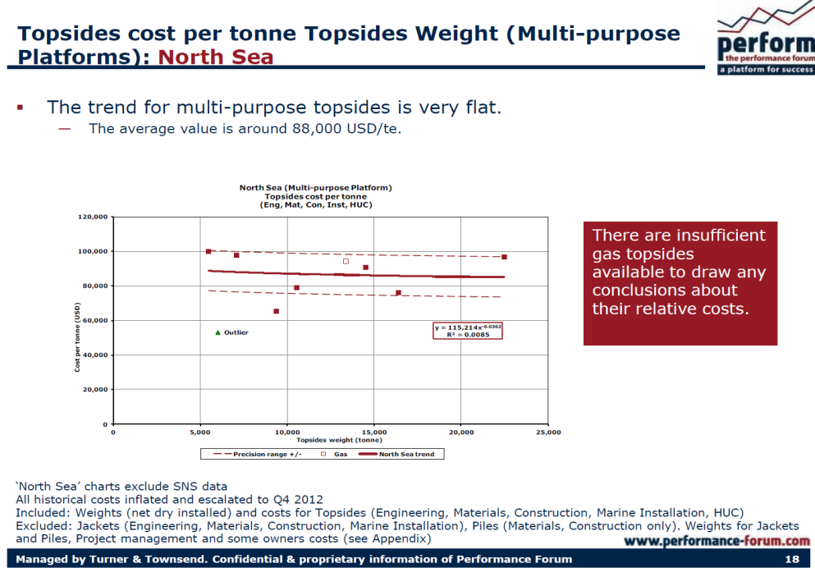**Appendix A**

**Asset value based on asset weight**

**The following provides an example of a simple weight based value validity check.**

Asset weights should be easily obtainable by assured from the client via the broker. Asset weights are publicly available on information repositories such as Wood Mackenzie therefore there should be no reservations from the assured in providing this information.

Some assureds are currently using benchmarking produced by Turner & Townsend to calculate asset replacement value based on both Topsides and Jacket weight. The example graphs below provide topside cost per tonne vs topsides weight and jacket cost per tonne vs jacket weight respectively for North Sea platforms.

Although these are North Sea specific, they could usefully serve as a baseline and then used with a prescribed set of multipliers for alternate locations such as more complex, more remote, less mature etc. These should be used with a degree of caution as they are very generic and have exclusions that would be insured. Care should also be taken to understand the date validity of the information, which in turn may need to be indexed.

