JNRC - Learning Opportunity Notification (LON) – 010
Incident Details |  | Incident Impact
Incident | Blowout from Well 22/30c – G4 on Elgin Offshore Wellhead Platform | People | 238 people evacuated from the wider Elgin Complex (platform and jack-up) in addition to all non-essential personnel from nearby Shearwater Platform and Hans Deul Drilling Rig
Date of Incident | 25 March 2012 | Environment | 6,172 te of gas and condensate released in 51 days
Location/Country | Elgin/Franklin Field, UK Continental Shelf, 200 km east of Aberdeen, Scotland | Asset (OPSR advised loss at time of incident) | Undisclosed (estimated >£300 million for well control and loss of production)
Type of Incident | Blowout | Reputation | Short-term negative share price impact for Operator
Asset Type | High Pressure High Temperature (HPHT) field in 93m water depth producing 130,000 bpd oil plus gas at time of incident | 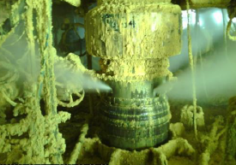  Gas Release at G4 Well-Head (Total Elgin Storyboard)
Asset Status | Undergoing well kill at the time of the incident
Immediate Cause | Stress Corrosion Cracking (SCC) due to the interaction between the thread lubricant and the calcium bromide completion fluid (brine)
Similar Root Cause Incidents | Vinland, Sable Island/Canada in 1984, Montara, Timor Sea/Australia in 2009 and Macondo, Gulf of Mexico in 2010. In all cases there was an unexpected influx of well fluids (kick) and loss of hydrocarbons (blowout)
Date Updated | 16 February 2026
Incident Description
First gas was exported from the Elgin facilities (including the G4 well) in March 2001.

At approximately 12:30 on Sunday 25 March 2012 an uncontrolled release of hydrocarbons / blowout occurred on the Elgin Well Head Platform (EWHP), bridge-linked (90m) to the Elgin Process/Utilities/Accommodation platform (PUQ), during an attempted intervention on well G4 when attended by the Rowan Viking jack-up drilling rig.

The Elgin/Franklin wells consist of a production tubing (through which the production fluids from the reservoir flow to the topsides production facilities) and a number of casing strings of different diameter and associated well annuli designated as A, B and C (inner to outer).

The G4 well was not in operation at the time of the loss of well control and had been isolated for a year prior to the incident. A chalk interval (within the overlaying rock formations) began to unexpectedly leak gas flowing via the well annuli into the D annulus (between the 20” casing and the 30” conductor). As the 30” conductor is not part of any hydrocarbon containment system, the wellhead ports are open to atmosphere through which pressurized hydrocarbons entering the D annulus were released. The leak path from chalk interval to atmosphere was complex and involved sequential failure of the three main (A, B & C) casings.

Following the hydrocarbon release the platform was shutdown and depressurized. All workers (238 people) were evacuated from the platform and rig and the coastguard imposed a shipping and aircraft exclusion zone (3.2km) around the Elgin platform. Non-essential personnel from nearby Shearwater Platform and Hans Deul Drilling Rig were also evacuated. All power was shut down. The flare continued to burn until 30 March 2012.

The hydrocarbon release continued for approximately 51 days until the well kill (using heavy mud) was completed on 15 May 2012. This was a complex and hazardous operation and required gas dispersion modelling to ensure safe location and operation of the West Phoenix semi-submersible rig providing the kill mud.

Sequence of events for the G4 well - pre-event and event:

- Jan 2011: 7” Liner collapsed
- Feb 2011: Deep plug set to isolate Fulmar reservoir
- 25 Feb 2012: 10¾” Production Casing (A) failure and communication across B & C annuli, albeit hydrocarbons contained, and pressure initially controlled by bleeding
- 05 Mar 2012: Well intervention started from attending jack-up drilling rig
- 25 Mar 2012: Uncontrolled gas release after failure of C annulus due to over pressure, platform & jack-up evacuated
- 15 May 2012: Well killed with heavy mud from 2nd attending semi-submersible rig
- 16 June 2012: Contingent single relief well suspended (spudded 18 April) - being drilled 1.6 km from the EWHP (a 2nd relief well was planned but not started)
- 24 Oct 2012: Well finally secured with 2nd plug installed from attending jack-up
- 09 Mar 2013: Production from Elgin restarted
Refer to References for Well Schematic and suspected leak path.

Incident Analysis and Findings (including Causal Factors)
Immediate Causes:

- Production casing (10 ¾”) failure below design pressure –allowing communication between A and B annuli, leading to communication between B and C annuli. Final failure of the 20” casing allowed communication with the D annulus within the well conductor, which terminates at the wellhead where there are four ports open to atmosphere subsequently releasing hydrocarbons.

- Increased gas mobility in the HOD formation (chalk horizons) – Initially (during the field development) the HOD formation (chalk layer) had low permeability, however over time there was rearrangement of the overlying chalk caused by compaction of the Fulmar reservoir due to production, increasing permeability and gas mobility. Chalk gas reached the A annulus through suspected breaches in the production casing and the B annulus through a small crack (micro-annulus) in the cement.

- Over pressurisation due to well intervention limitations – the intervention programme for G4 was not able to kill the well before the C annulus was overpressured because the required back pressure at the top of A annulus to kill the well whilst keeping B and C annuli within the required integrity operating windows was not achieved. Frequent bleeding operations of B and C annuli pulled more gas into the well.

Underlying Cause:

Neither the intermediate casing (B) nor the surface casing (C) would have been expected to fail at the pressures seen on G4 in February (for the intermediate casing) and March (for the surface casing) in 2012. Once the casing sections were recovered, it was found that the joint connecting two casing sections had failed at a depth of 2,094 metres. A full metallurgical examination (by The Welding Institute-TWI) of the joint established that the failure mechanism was stress corrosion cracking – SCC (or environmentally assisted cracking) of the threaded portion of the casing and the casing joint. The cause of SCC was identified as an interaction between the thread lubricant (thread dope) and the calcium bromide brine completion fluid in the B annulus, in contact with the outside of the production casing (A). This particular type of SCC and the identified failure mechanism, were not considered foreseeable in the type of casing material.

Root Causes
Equipment Failure |  |  |  | Human Performance |  |  |  | Other
Repeat Failure | x | Unexpected Failure | x | Human Engineering |  | Training |  | Sabotage
Preventive/Predictive Maintenance | x |  |  | Procedures | x | Management System | x | Natural Peril
Design |  |  |  | Communications |  | Quality Control |  | Other
Equipment/Parts Defective |  |  |  | Immediate Supervision
Lessons Learned
- Well Failure Mode Risk Assessment and Design Reviews to establish Well Integrity Criteria
Well integrity must be managed as a life-cycle process with robust barrier philosophy

- Well Integrity Operating Philosophy Implementation, including instructions in the event a well fails any of the well integrity criteria
The Well Integrity Management System (WIMS) must be updated upon detecting well abnormal behaviour, to ensure relevant mitigation measures are in place and will reduce the risk
to as low as reasonably practical (ALARP)

- Monitoring and Reporting of Well Annuli Compliance with Well Integrity Criteria
Annulus management systems should include proactive risk assessments

- Full Technical Review of all Wells vs Current Formation Conditions

- The well barriers isolating the reservoir from the atmosphere should be preserved (2 minimum) at all times, any change in well conditions downgrading this should be subject to a comprehensive risk assessment to define and implement any compensatory and/or corrective action

- Procedures for Preparing and Implementing Well Intervention Programmes

- Emergency Response Planning and Drills (critical for major accident hazard management)

The G4 incident investigation evidenced the loss resulted for a combination of several events, some of which were difficult to predict, else not being fully considered as part of ongoing assessments. Changing field conditions, presence of (known) failed well barriers resulting in sustained casing pressures and limitations of design of outer casings all led to a flow path to surface being created.

Noted that emergency response managed down manning from 238 to 19 essential persons in just over 3 hours, with follow-up commitment of three further intervention rigs, stand-by clean-up vessels, guard vessels and overflights.

References
- The Elgin Incident Investigation by Health & Safety Executive (HSE) Hazardous Installations Directorate, Energy Division, March 2014
- Elgin G4 Gas Release: What Happened and The Lessons to Prevent Recurrence - Society of Petroleum Engineers Paper 168478 March 2014
- Elgin Franklin G4 Well Incident – The Importance of Well Integrity Management by Howden Specialty Risk Engineering
- Elgin G4 Gas Leak Incident Total May 2012
- Well Schematic

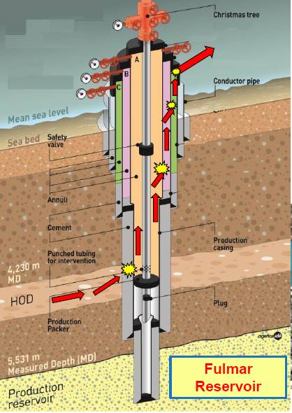

G4 – Well Schematic and Suspected Leak Path (Total Elgin Storyboard)

